June 2022 Paper A Recalls
- Pregabalin MOA. Options – Calcium, NMDA, AMPA
- potent ligand for the alpha-2-delta subunit of voltage-gated calcium channels
- Pregabalin does not bind to plasma proteins and is excreted virtually unchanged by the kidneys
- It is not subject to hepatic metabolism and does not induce or inhibit liver enzymes such as the cytochrome P450 system
- A man unable to follow order - Ideational Apraxia
an inability to follow a sequence of actions in the correct order e.g. Take a match out a box and strike it with your left hand

Apraxia
Apraxia is the inability to carry out learned voluntary movements (assuming everything works and they are not paralyzed).
The main types of apraxia are as follows:-
- Limb kinetic apraxia – (dominant) an inability to make fine/ delicate movements
- Ideomotor apraxia – (both or dominant) an inability to follow out learned tasks when given the necessary objects e.g. if given a hairbrush they try to write with it
- Constructional apraxia - an inability to copy a picture or combine parts of something to form a whole
- Ideational apraxia - an inability to follow a sequence of actions in the correct order e.g. Take a match out a box and strike it with your left hand
- Oculomotor – (bilateral occipital parietal) an inability to control eye movements

- A man unable to use hammer, uses it later - Ideomotor Apraxia
↑ Above Q

- Which neuronal cell that releases glutamate
Astrocyte
Astrocytes can respond to various neurotransmitters and factors and in turn release glutamate, d-serine, ATP, and gamma-aminobutyric acid (GABA) as well as prostaglandins and neuropeptides.

- Man had accident 5 years previously, now has bilateral coarse tremors and eye not focusing (reduced gaze) , sleeping tablets made his tremors better; which diagnosis -?PTSD, ?Adjustment disorder, ?Post concussional syndrome

? 5 years so No concussion PTSD less likely

- Where can you find the Dentate gyrus? -
Hippocampus > Episodic Memory

- Receptor matching:
Memantine Non-competitive NMDA antagonist
Buproprion Norepinephrine-dopamine reuptake inhibitor (NDRI), and nicotinic acetylcholine receptor antagonist
Naltrexone Reversible competitive antagonist at µ and ĸ receptors (δ receptor antagonist to a lesser extent)

- Imprinting
phase-sensitive attachment
Lorenz
Imprinting is rapid
Unreinforced
occurs during a clearly defined period (known as the critical period)
Irreversible.
- Neuroimaging findings in PTSD, , Neuronal axon damage, Antipsychotic effect
REDUCED NAA IN ACC & HIPPOCAMPUS
PTSD Increased amygdala activation and smaller amygdala volumes are most consistently reported.

Smaller hippocampal volume commonly appear repeatedly

CJD

vCJD Pulvinar Sign: seen in Bilateral posterior basal ganglia high signal and thamalus

Antipsychotic effect (basal ganglia increase volume and white matter)
increased ventricular volume and reduced frontal and medial temporal lobe grey matter over time

- Tetrabenazine receptor of highest affinity - ?specific SERT
VMAT-2* inhibitor, Reversible
- Ketamine
NMDA Antagonist, high affinity
- Form of therapy where ppl admit feeling helpless/powerless
Learned Helplessness , CBT

- EMI: EEG Waves – Polyspikes,3-6 hertz, 2-4 hertz

3-6 hertz, Myoclonic
2-4 hertz Atypical Absence

- Exposure of a patient to alcohol and drug misuse without actually taking the substances
Behavior therapy
- Duloxetine use Liceneced for GAD, Pain disorders (60 mg)
- A man whose friend died in a motor cycle accident an now has a paralyzed arm despite doctors not finding any neuro issues with the arm - ? Conversion disorder
- Child waking up agitated
Sleep terrors are characterized by a sudden arousal from slow wave sleep with a piercing scream or cry, accompanied by autonomic and behavioural manifestations of intense fear.

Sleep terrors manifest as a severe autonomic discharge, with tachycardia, tachypnea, flushing of the skin, diaphoresis, mydriasis, decreased skin resistance, and increased muscle tone. The patient usually sits up in bed, is unresponsive to external stimuli, and, if awakened, is confused and disoriented. Amnesia for the episode occurs, although sometimes there are reports of fragments or very brief vivid dream images or hallucinations. The episode may be accompanied by incoherent vocalizations or micturition

- The woman with multiple gynaecological, gastric pain…for 10 years , all tests normal, convinced drs missed something-? Delusional disorder, ? Somatisation

- Area of brain affected in auditory hallucinations-
Language (Wernicke's area), and sensation of sound. Reduced gray matter volumes in the superior temporal gyrus (STG) (increase blood flow and metabolism) have been reported in patients with schizophrenia
Decrease activation of the frontal lobe

- Area of brain involved in Default mode network
anatomically the medial frontoparietal network (M-FPN),

medial prefrontal cortex,
posterior cingulate cortex/precuneus
angular gyrus.

Active when a person is not focused on the outside world and the brain is at wakeful rest, such as during daydreaming and mind-wandering
Also Active thinking about themselves, remembering the past, and planning for the future

- Example of activity that involves the use of default mode network
Above
- Piaget, Kohlberg, Eisenberg, Erikson, Bowlby theories
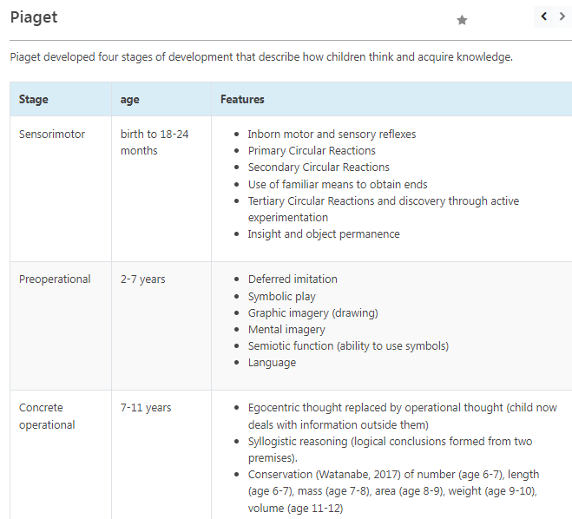

Koherlberg
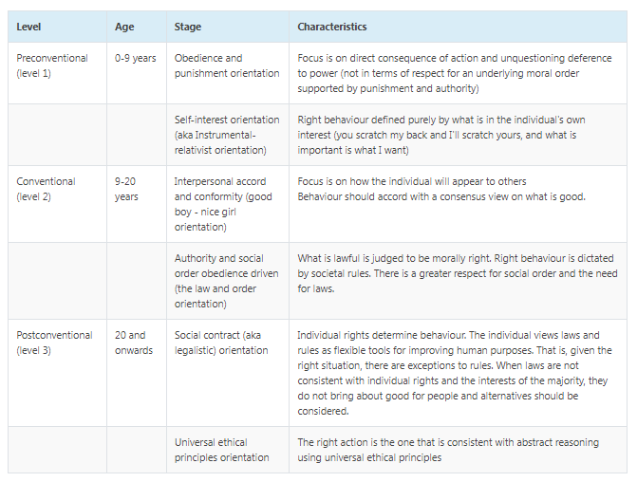

- Locus coeruleus and the neurochemical pathway
Noradrenergic projection originates,at the locus coeruleus (pons) and ascends to most of the cortex via medial forebrain bundle.
noradrenergic projections also descend to the Spinal cord

- Causes of Postural hypotension as a side effect and which receptor
Alfa one antagonist
- Alpha 2 blockade
Agitation
Impotence
- 5HT2a
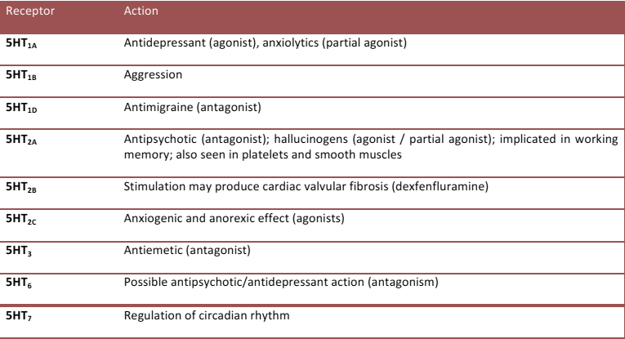

- Antidepressant with discontinuation syndrome risk – Venlafaxine (paroxetine and amytriptiline)?, Fluoxetine?
- Agomelatine mode of action/receptor
agonist at melatonin M1 and M2 receptors and as an antagonist at 5HT2C and 5 HT2B receptors.
- Which is extensively metabolized by CYP40
CYP2D6 (Antidepressants except sertraline and citalopram??)
CYP 3A4 (benzodiazepines)

- Hormone produced by the hypothalamus that regulates appetite – Neuropeptide Y, orexin and ??
PPY, PPC, Cholecystokinin
- Hormone produced by the adipose tissue that regulates appetite – Leptin, Neuropeptide Y
- Neuropeptide Y is produced by the hypothalamus and increases appetite
- Leptin is produced by adipose tissue and reduces appetite
- Ghrelin is produced mainly by the gut and increases appetite
- Cholecystokinine (CCK) is produced mainly by the gut and reduces appetite

- Which pro-inflammatory interleukin is elevated in depression- IL 11?, IL 4?, IL 6

- Altruism- ? innate, ?volunteering makes life better for old people
Vicarious but constructive and instinctually gratifying service to others.
It includes benign and constructive reaction formation, philanthropy, and well repaid service to others. Altruism differs from projection and acting out in that it provides real , not imaginary, benefit to others and from reaction formation that leaves the person using the defence at least partly gratified

- MOA Cocaine, MDMA

Cocaine (and methylphenidate) directly blocks the dopamine transporter (DAT)
MDMA Blocks SERT Monoamine Transporter

- Hospital management prioritizing early intervention unit for funding over the rehabilitation unit cos more pts use it. This is an example of which principle? – Autonomy?, Beneficence?, Non-maleficence?, Utilitarian
The greatest good for the greatest number.

- Vortioxetine receptors
5HY1A Full agonist
5HT1B partial agonist
Antagonist at
5HT3, 5HT7,5HT1D
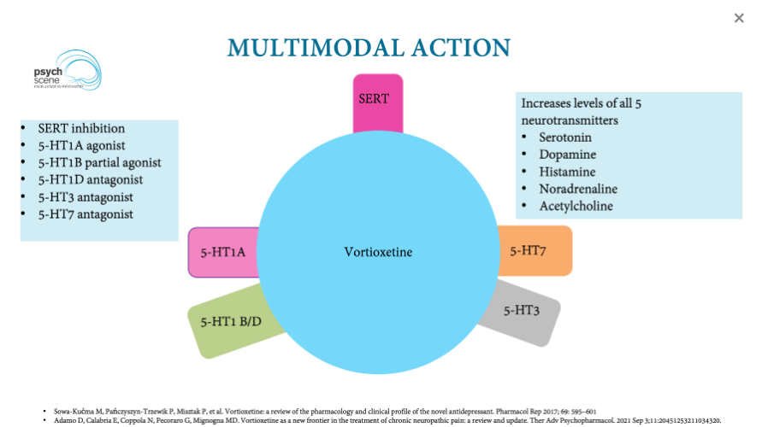

- Antidepressant for a patient with hyponatremia
Bupropion , Mirtazapine, MOAIs

- Ion implicated in schizophrenia ?? (ca and k??)

These alterations cause the most important inhibitory current in the brain, called GABA_{A}, to become excitatory. Inhibiting the transporter activity with bumetanide, an FDA-approved diuretic, rescued cognitive symptoms in mouse models of schizophrenia.
The polarity of the GABA_{A}-mediate current is determined by the balance of two chloride transporters: NKCC1 and KCC2

- Brain organoid of pluripotent cell is at what age?, what are the drawbacks?
2 months
6+ months ..
Drawback...lack of reproducibility, lack of blood supply, ventricles are not well-demarcated, immunity system, ethical issues.
- Area under the curve means?
plasma concentration of a drug versus time

- The graph on arousal and performance
The Yerkes-Dodson law is a model of the relationship between stress and task performance. It proposes that you reach your peak level of performance with an intermediate level of stress, or arousal.

- Piagets assimilation, accommodation and equilibrium
Assimilation – The process of taking new information into an existing schema.

Accommodation – Altering a schema in view of additional information.

- Differentiating vascular dementia from alzheimers
Need Options
- Scale that has ‘no pain’ on one end and ‘excruciating pain ‘ on the other end - ? likert scale. ? Semantic ?Nominal ?Ordinal
Ordinal

- Psilocybin receptor
5 HT2A agonist

- Purine properties
Aromatic
- Child language abilities at age 1,2,13 years
Phonemic expansion at bubbling phase
Phonemic contraction at - 9-10 months
Expansion in language development - 2-3 years
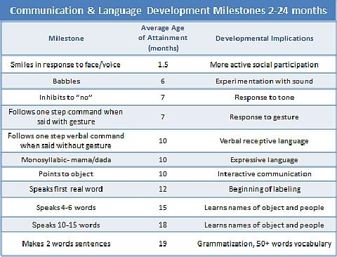
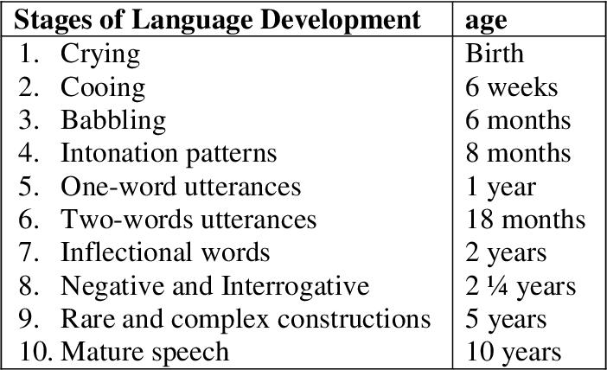

- What not to take with fluoxetine - ? Aspirin, ?NSAIDs

NSAIDs: NICE guidelines advise ‘do not normally offer SSRIs’, but if given co-prescribe a proton pump inhibitor
Warfarin / heparin: NICE guidelines recommend avoiding SSRIs and considering mirtazapine
Aspirin: see above
Triptans: avoid SSRIs

- Indicator for clozapine induced myocarditis

Myocarditis:

Myocarditis is rarely seen in clozapine use but carries with it a high mortality.

Studies have estimated the risk of clozapine-induced myocarditis to be 1 in 500 to 1 in 10,000 (Hass, 2007). The true risk is likely closer to the 1 in 500 rate, as often only a minority of adverse medication-related events are diagnosed and reported.

Most cases of myocarditis occur early in the course of clozapine treatment. The condition was detected within 16 days (median) of initiating clozapine in a study of 116 cases (Hass, 2007). Approximately 80 percent of cases of clozapine-induced myocarditis occur within four weeks of drug initiation, and 90 percent occur within eight weeks.

Postmortem examination has most commonly revealed damaged myocytes and eosinophilic infiltration suggesting a type I Ig E-mediated acute hypersensitivity reaction.

Some patients will have a mild and temporary increases in inflammatory markers and eosinophils at the beginning of treatment without progression to myocarditis.

Subsequent use of clozapine in cases with clear clozapine-induced myocarditis leads to recurrence of myocarditis in most cases when the drug is restarted.

Features include:-

Fever
Chest pain
Tachycardia
Dyspnoea
Flu-like symptoms
Elevated eosinophil count
Elevated cardiac enzyme levels

The gold standard for diagnosis of myocarditis is an endomyocardial biopsy, but this is not a practical initial approach.

Cardiac biomarkers, including creatine kinase and troponin, are routinely measured in patients with suspected myocarditis. Creatine kinase has been shown to be inferior to troponin for assessing myocardial injury, and is not useful for screening because of its low predictive value.

Outcomes of clozapine-induced myocarditis are poor, with mortality rates as high as 50%

- Fetal malformation in Sodium Valproate

Neural tube defects (1-4)%, facial dysmorphism, cleft lip and palate (1-2)%, craniostenosis (skull contractions), cardiac, renal and urogenital defects, limb defects (including bilateral aplasia of the radius).

- Which part of the frontal lobe is prominent in teenagers? Options
- Dorsomedial prefrontal
- Dorsolateral prefrontal
- Medial orbitofrontal
- Lateral orbitofrontal
NO ANS Found

- EMI: When one’s schema is corresponding with one’s experiences. Options
- Accomodation
- Assimilation
- Equilibrium
- Organisation
- Centration

Assimilation
- Piaget defined assimilation as the cognitive process of fitting new information into existing cognitive schemas, perceptions, and understanding. Overall beliefs and understanding of the world do not change as a result of the new information.
- Assimilation coccurs when the new experience is not very different form previous experiences of a particular object or situation we assimilate the new situation by adding information to a previous schema.
- This means that when you are faced with new information, you make sense of this information by referring to information you already have (information processed and learned previously) and try to fit the new information into the information you already have.
- For example, a 2-year-old child sees a man who is bald on top of his head and has long frizzy hair on the sides. To his father’s horror, the toddler shouts “Clown, clown” (Siegler et al., 2003).
- For example, a baby learns to pick up a rattle he or she will then use the same schema (grasping) to pick up other objects.

Accommodation
- Accommodation: when the new experience is very different from what we have encountered before we need to change our schemas in a very radical way or create a whole new schema.
- Psychologist Jean Piaget defined accommodation as the cognitive process of revising existing cognitive schemas, perceptions, and understanding so that new information can be incorporated. This happens when the existing schema (knowledge) does not work, and needs to be changed to deal with a new object or situation.
- In order to make sense of some new information, you actual adjust information you already have (schemas you already have, etc.) to make room for this new information.
- For example, a baby tries to use the same schema for grasping to pick up a very small object. It doesn’t work. The baby then changes the schema by now using the forefinger and thumb to pick up the object.
- Also, a child may have a schema for birds (feathers, flying, etc.) and then they see a plane, which also flies, but would not fit into their bird schema.
- In the “clown” incident, the boy’s father explained to his son that the man was not a clown and that even though his hair was like a clown’s, he wasn’t wearing a funny costume and wasn’t doing silly things to make people laugh.
- With this new knowledge, the boy was able to change his schema of “clown” and make this idea fit better to a standard concept of “clown”.

Equilibration
- Piaget believed that all human thought seeks order and is uncomfortable with contradictions and inconsistencies in knowledge structures. In other words, we seek 'equilibrium' in our cognitive structures.
- Equilibrium occurs when a child's schemas can deal with most new information through assimilation. However, an unpleasant state of disequilibrium occurs when new information cannot be fitted into existing schemas (assimilation).
- Piaget believed that cognitive development did not progress at a steady rate, but rather in leaps and bounds. Equilibration is the force which drives the learning process as we do not like to be frustrated and will seek to restore balance by mastering the new challenge (accommodation).
- Once the new information is acquired the process of assimilation with the new schema will continue until the next time we need to make an adjustment to it.
- Equilibration is a regulatory process that maintains a balance between assimilation and accommodation to facilitate cognitive growth. Think of it this way: We can't merely assimilate all the time; if we did, we would never learn any new concepts or principles.
- Everything new we encountered would just get put in the same few "slots" we already had. Neither can we accommodate all the time; if we did, everything we encountered would seem new; there would be no recurring regularities in our world. We'd be exhausted by the mental effort!

- Innate ability to gather information and integrate available info into a system of knowledge. Same options as Q52

As Above

- Stimulated part of the brain in Visual hallucinations, Auditory hallucinations
Visual hallucinations were associated with reduced volume in bilateral occipital regions, right supramarginal gyrus and left fusiform gyrus, bilateral dorsolateral prefrontal cortex, frontal pole and the middle portion of the left cingulate gyrus. Lingular gyrus.

Auditary Hallucination
left temporal lobe, in the peri-Sylvian region.

- Progranulin gene- FTD

- Confabulation . Options :
- Can only occur in Korsacoff syndrome
- May occur in clouded consciousness
- There is deliberate falsification of facts
- Autobiographical memory
- There is subjective awareness of memory impairment
Confabulation is a falsification of memory occurring in clear consciousness associated with organic states.
Suggestibility is a prominent feature of confabulation. It is often described in Korsakov syndrome. There
can either be confabulation of embarrassment or of fantastic nature

- Tau positive and ubiquitin negative in FTD

Familial frontotemporal dementia with ubiquitin-positive, tau-negative inclusions

- Which is not a risk for SSRI induced hyponatremia ? Options:
- Male sex
- Low body mass
- Low sodium level
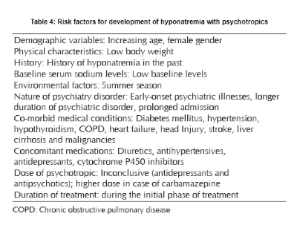
- One of these is not a risk factor for delayed speech impairment. Options:
- Immigration status??
- Maternal alcohol intake
- Maternal smoking in pregnancy
- Large families
- Reduced cognitive stimulation??
A number of risk factors are associated with delayed speech and language (Nelson 2006):-
- Family history
- Male gender
- Twins
- Lower maternal education
- Childhood illness
- Being born late in the family order
- Young mother at birth
- Low socioeconomic status
- Maternal alcohol intake
- Maternal smoking in pregnancy
- Which of these drugs do not cross the blood brain barrier? Options:
- Amisulpride, Dopamine, serotonin
- l tryptophan and l dopa can cross BBB
- Olanzapine
- Quetaipine
- Clozapine
- Risperidone
()
- Risk factors for Qtc prolongation. Options:
- Male sex
- Sinus tachycardia
- Hypokalemia
- Tardive dyskinesia- D2 hypersensitivity
- Orthostatic hypotension- Alpha 1 adrenergic blocker
- A cell was infected by toxins and inflammatory markers seen around the mileu. What process is this? Options:
- Apoptosis
- Necrosis
- Entosis
- Excitoxicity
- Rate limiting step in alcohol metabolism. Options:
- Acetaldehyde dehydrogenase
- Alcohol dehydrogenase
- Alcohol hydroxylase
- How to reduce groupthink? - open debate
- ADHD – DRD4
- Ketamine MOA – NMDA antagonist
- Cocaine receptor/MOA DAT
The rewarding effect of cocaine is related to increase in dopamine concentration in limbic regions due to either dopamine transporter blockade or direct occupancy of D2 receptors. D1 is implicated in conditioned response to cocaine.
- Southern blot- specific DNA sequence
- Locum 1 hr extra – fixed interval
- Gambling- variable ratio
- Caffeine is (Adenosine antagonist) and reversed by:
- Adenosine agonist
- GABA
by Adenosine agonist readily cross BB barrier , it is methyl xanthine derivative and completely reverses the effect of adenosine
74. Thomas scale for infants. Options:
- Anger
- Impulsivity
- Control

Points from notes
- Activity
- rhythmicity
- approach/withdrawal
- adaptability
- intensity
- threshold
- mood
- distractibility
- attention span / persistence
75. Which is part of Maslow’s original hierarchy of needs – Esteem? 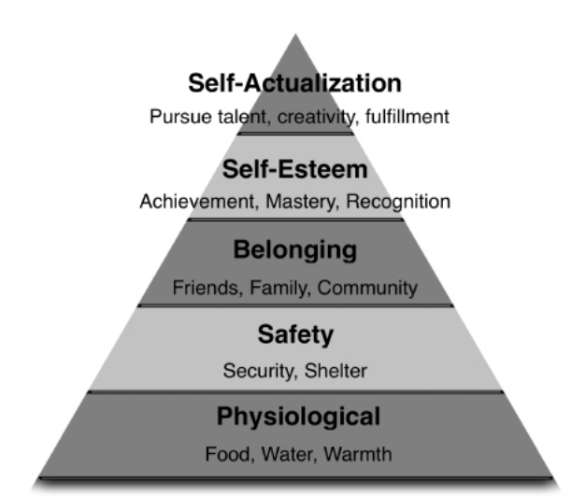
Monotropy attachment to single figure mainly mother According to Bowlby, the strong innate tendency to attach to one adult female is seen – this is monotropy

76. Changes in pregnancy. Options:
- Increase in gastric PH
- Increase in GFR
- Increase in gastric motility
Pregnancy is associated with several pharmacokinetic changes:
 Delayed gastric emptying,
 Decreased GIT motility,
 Increased volume of distribution (5%),
 Decreased drug-binding capacity,
 Decreased albumin level
 Induced liver metabolic pathway,
 Increased GFR & renal clearance.

77. Monotropy attachment to single figure mainly mother According to Bowlby, the strong innate tendency to attach to one adult female is seen – this is monotropy
FISH: used for deletion syndromes
Trinucleotide repeats: PCR (most modern) & Southern blot also

